ONEWAY CRT BY WOKE
/STATISTICS DESCRIPTIVES HOMOGENEITY WELCH
/PLOT MEANS
/MISSING ANALYSIS.

Oneway

Notes
Output Created |  | 05-May-2019 23:49:31
Comments
Input | Active Dataset | DataSet0
Input | Filter | <none>
Input | Weight | <none>
Input | Split File | <none>
Input | N of Rows in Working Data File | 30
Missing Value Handling | Definition of Missing | User-defined missing values are treated as missing.
Missing Value Handling | Cases Used | Statistics for each analysis are based on cases with no missing data for any variable in the analysis.
Syntax |  | ONEWAY CRT BY WOKE  /STATISTICS DESCRIPTIVES HOMOGENEITY WELCH  /PLOT MEANS  /MISSING ANALYSIS.
Resources | Processor Time | 00 00:00:00.171
Resources | Elapsed Time | 00 00:00:00.167

[DataSet0]

Descriptives
 | N | Mean | Std. Deviation | Std. Error
Between 1-4 hours | 5 | 9.6000 | 2.41661 | 1.08074
Between 4-6 hours | 9 | 9.1222 | 4.12728 | 1.37576
Between than 6-8 hours | 3 | 9.2667 | 2.10079 | 1.21289
More than 8 hours | 13 | 7.7846 | 3.34610 | .92804
Total | 30 | 8.6367 | 3.32291 | .60668

Descriptives
 | 95% Confidence Interval for Mean |  | Minimum | Maximum
 | Lower Bound | Upper Bound | Minimum | Maximum
Between 1-4 hours | 6.5994 | 12.6006 | 5.80 | 11.60
Between 4-6 hours | 5.9497 | 12.2947 | 4.00 | 14.00
Between than 6-8 hours | 4.0480 | 14.4853 | 7.20 | 11.40
More than 8 hours | 5.7626 | 9.8066 | 3.20 | 12.40
Total | 7.3959 | 9.8775 | 3.20 | 14.00

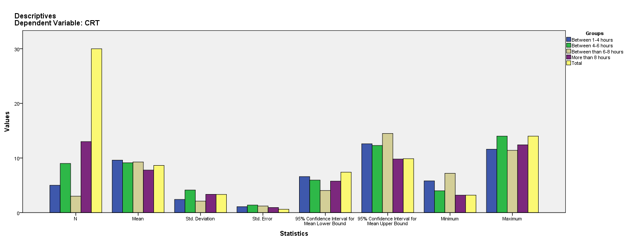

Test of Homogeneity of Variances
CRT
Levene Statistic | df1 | df2 | Sig.
2.608 | 3 | 26 | .073

ANOVA
CRT
 | Sum of Squares | df | Mean Square | F | Sig.
Between Groups | 17.391 | 3 | 5.797 | .498 | .687
Within Groups | 302.819 | 26 | 11.647
Total | 320.210 | 29

Robust Tests of Equality of Means
CRT
 | Statisticª | df1 | df2 | Sig.
Welch | .564 | 3 | 8.805 | .653
a. Asymptotically F distributed.

Means Plots

